


Thank you for joining us on the Robotics Fulfilment Centre Tour on Kahoot!
We can’t wait to introduce you to the incredible technology and people who make Amazon possible. Use this facilitation guide to provide an excellent tour experience for students at home or in the classroom!
1. Prepare for the tour
- Review the key learnings and facilitation guide document below. Click through the tour (link below) on your own.
- Distribute graphic organiser (PDF, Word) to students if desired.
2. Select your tour style
Host a tour with student devices  A host projects the tour to a group and students join to compete against each other from separate devices. | Project the tour without student devices  The host projects the tour to a group without students joining on separate devices. | Share the tour for independent student play  Students complete the tour by themselves on their own devices. Teacher cannot see student responses.

For additional support in setting up Kahoot, visit: https://support.kahoot.com/hc/en-us
3. Facilitate the tour
- Use the guide below to walk students through the tour. Ask students to share their thoughts or respond to questions to build more interaction
- To advance slides, click “Got it” in the top right corner
- Use our Teacher Toolkit for optional follow up activities and print completion certificates
Kahoot! Tips
- If the video clips are playing too softly, check that the volume bar on the YouTube video is at maximum volume
- There is no go back feature. If you need to go back to a video, the links to the segments on YouTube are provided in the facilitation guide below
- Warning: Hitting the space bar auto-advances the slide with no go-back feature

Thank you for encouraging the next generation of future engineers!

Amazon Primary FC Tour
Slide # | Slide Image | Facilitation Tips | Notes
1  30 sec | 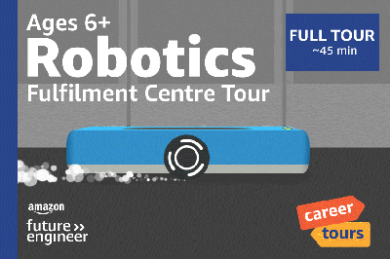 | Say: “You may have heard of the company Amazon before. You may have seen Amazon lorries and vans delivering packages around your neighbourhood.  Today we’re going to take a virtual school trip to a fulfilment centre where Amazon fulfils and sends out customer orders to learn about how computer science makes it all possible.”
2  1 min | 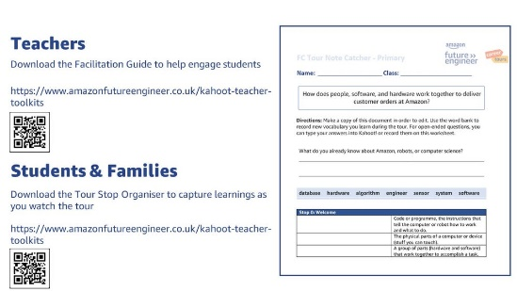 | If you’d like your students to access digital notes, have them access and create a copy of the student note catcher.  If using paper note catchers, this would be the time to distribute.
3  1 min | 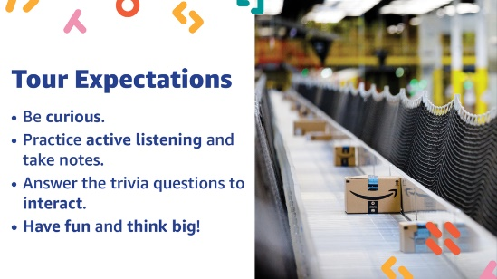 | Set tour expectations with your class.  Read the expectations to students.  Say: “On the next slide you’ll answer if you agree or disagree with the statement ‘Right now, I am interested in career opportunities in computer science and technology.’ Remember, there is no right answer and this does not count towards your points.”
4  1 min | 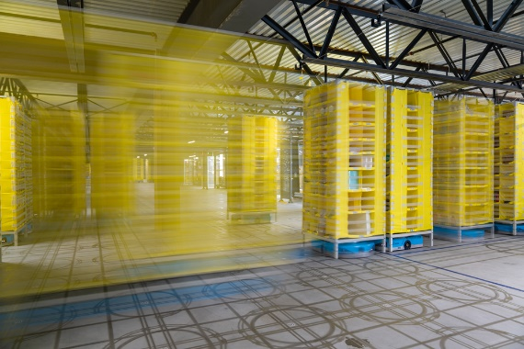 | Read the question and on-screen answer choices to students. “Right now, I am interested in career opportunities in computer science and technology.”  After finishing the question, prepare students for the next one.  Say: “Before we begin, I want to know – what do you already know about Amazon, robots or computer science? On the next slide you’ll answer what you already know.”
5  1 min 30 sec | 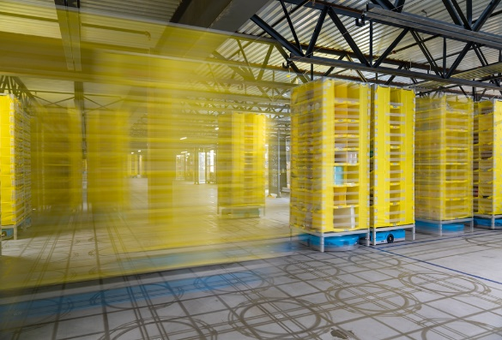 | Students should write answers on their notecatcher, turn and talk, or share out loud in a group. “What do you already know about Amazon, robots, or computer science?”  Select a few answers and read them aloud to the class or have students share answers.  Say: “It’s time to begin our tour!”
6  2 min 30 sec | 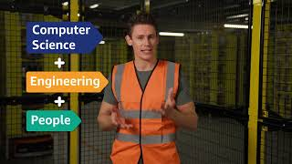 | Show Video 1. Video is 2:17 in length.  Say: “It’s time for your first trivia question. What do you think is the fastest Amazon has ever delivered a customer order? Remember points are awarded for getting it right AND how fast you answer!”
7  1 min | 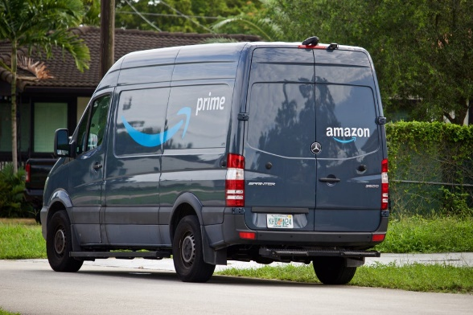 | Read the question and on-screen answer choices to students. “What do you think was the fastest Amazon has ever delivered a customer order?”  Answer: Under 30 minutes  Say: “Let’s get back to the tour to learn more about the ordering and fulfilment process.”
8  2 min 30 sec | 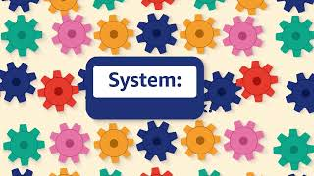 | Show Video 2. Video 2 is 2:24 in length.  After the video, say: “When I hit ‘Got it!’ / ‘Next’ we’re going to answer the two questions about what you just learned about software and hardware.”
9 - 10  2 min | 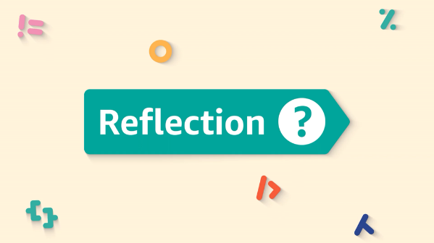 | Read the first question and on-screen answer choices to students. “The robots used to carry the pods are an example of…”  Answer: Hardware  Read the second question and on-screen answer choices to students. “The robots know where to go because … programmes its path using code.”  Answer: Software
11  2 min 30 sec | 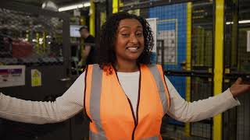 | Show Video 3. Video 3 is 2:13 in length.  After the video, say: “The Amazon Fulfilment Centres are massive. Some hold over 20 million items! When I click ‘Got it!’ you’re going to answer the following question, ‘How do you think Amazon organises and stores items in each fulfilment centre?’ You may not know the answer to this one just yet, but try your best!”
12  1 min |  | Read the question and on-screen answer choices to students. “How do you think Amazon organises and stores items in each fulfilment centre?”  Answer: Randomly – no organisation method.  Ask students why they think items are organised randomly in the FCs  Say: “Let’s see if your predictions are correct!”
13  3 min 30 sec | 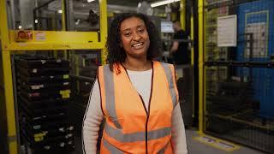 | Show Video 4. Video 4 is 3:20 in length.  After the video, say: “It’s time to reflect on what we’ve learned so far. You’re going to answer 2 questions about hardware, software and systems.”
14 -15  2 min |  | Read the first question and on-screen answer choices to students. “After an item is placed in a tote, the picker taps a sensor. The sensor is an example of….”  Answer: Hardware  Read the second question and on-screen answer choices to students. “Hardware, software, and people work together at the pick station to form a…”  Answer: System
16  1 min 30 sec | 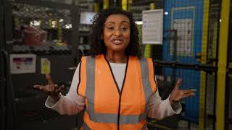 | Show Video 5. Video 5 is 1:16 in length.  Say: “Amazon packages come in all different size boxes and types of packaging. When I press ‘Got it!’ / ‘Next’ you’ll answer the question ‘How do you think a packer chooses the most efficient box for packing?”
17  1 min | 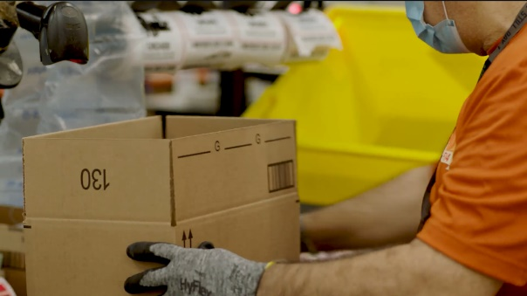 | Read the question and on-screen answer choices to students. “How do you think a packer at Amazon chooses the right-sized box?”  Answer: Following on screen commands based on previously recorded item measurements.  Say: “Now we’ll see how items are packaged at a pack station.”
18  3 min 30 sec | 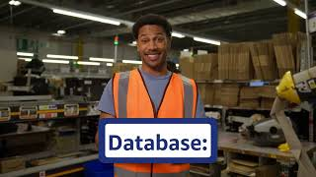 | Show Video 6. Video is 3:06 in length.  After the video, say: “It’s time to reflect on our investigation question. You’ll answer 2 questions related to hardware, software, and systems.”
19-20  2 min |  | Read the first question and on-screen answer choices to students. “… determines exactly which box to use for the items being packed.”  Answer: Software  Read the second question and on-screen answer choices to students. “The tape dispenser that spits out the right amount of tape is an example of…”  Answer: Hardware
21  2 min | 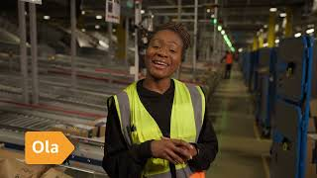 | Show Video 7. Video is 1:37 in length  After the video, say: “After your items are packaged, they need a check to make sure it’s correct and a label so it can be delivered to the correct address. How do you think Amazon makes sure your order is correct when the box is already sealed? You’ll answer that question then learn how!”  * If doing the tour in two parts, this is where the split occurs. Part is 2 available here to host and here for solo play.
22  45 sec |  | Read the question and on-screen answer choices to students. “How do you think Amazon checks that an order is correct if the box is already sealed?”  Answer: Weighs the item as it goes over a conveyor belt  Say: “Let’s watch how special technology at a station called SLAM makes this happen.”
23  3 min | 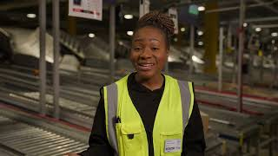 | Show Video 8. Video is 2:44 in length.  After the video, say: “It’s time to reflect on our investigation question in regards to shipping. On the next slides, you’ll answer 2 questions about our vocabulary words.”
24-25  1 min 30 sec |  | Read the first question and on-screen answer choices to students. “The SLAM station uses an algorithm to see if an order is correct. The algorithm is an example of _____.”  Answer: Software  Read the second question and on-screen answer choices to students. “The SLAM algorithm pulls the expected weight of the items from _____.”  Answer: A database
26  4 min 15 sec | 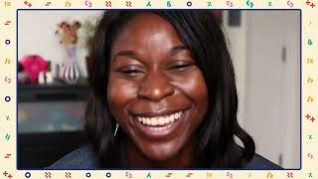 | Show Video 9. Video is 4:02 in length.  After the video, say: “You just met some engineers who made all of this technology possible. I want to know which of those careers or jobs most interests you! When I hit ‘Got it!’, you’ll answer the question, ‘Which career interests you most?’ This is a poll question, so there’s no right or wrong answer, and no points are given towards the leaderboard.
27  1 min | 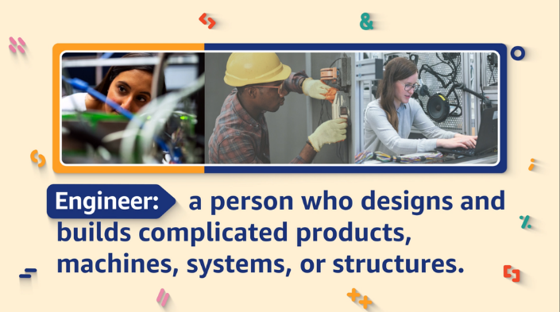 | Read the question and on-screen answer choices to students. “Right now, which career most interests you?”  Acknowledge student answers. Call on a few students to share out why they chose their answer.
28  1 min 30 sec | 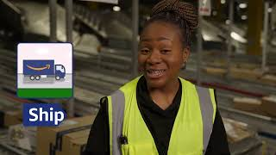 | Show Video 10. Video is 1:18 in length.  After the video, say: “We just saw so many ways hardware, software, and people work together to deliver customer orders! We’re going to answer a few questions that don’t count towards your points.”
29  1 min 30 sec |  | Students should write answers on their notecatcher, turn and talk, or share with the whole group. “What was your favourite part of the tour?”  Call on a few students to share out their favourite part of the tour and why.  Say: “Let’s do some rapid-fire trivia and poll questions to help us end the tour and determine our winner.”
30  2 min | 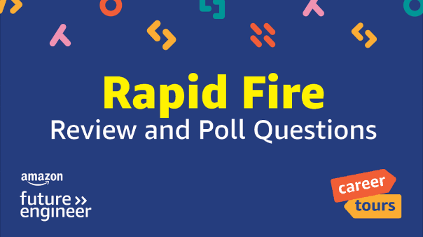 | Say: “Some of the questions will be polls, and some will be quiz questions and worth points. As a quick reminder, poll questions are worth 0 points.”
31  45 sec | 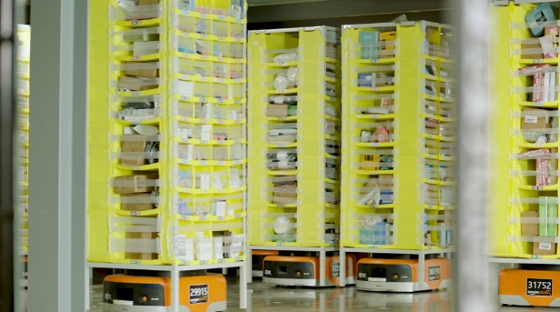 | Read the question and on-screen answer choices to students. “____ on the robots scan QR codes so the computer knows where the robot is on the FC floor.”  Answer: Sensors  Say: “Our next question is a poll. It is worth 0 points, but you’re going to think back before the tour. How interested were you in career opportunities in computer science and technology?”
32  45 sec |  | Read the question and on-screen answer choices to students. “Before this tour, I was interested in career opportunities in computer science and technology.”  Say: “Next up is a trivia question.”
33  45 sec | 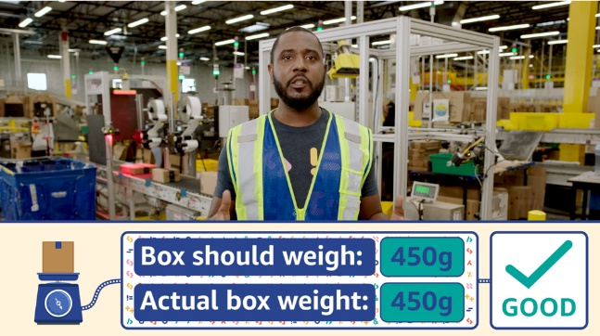 | Read the question and on-screen answer choices to students. “A(n) ___ matches the expected weight to the actual weight of items to perform a quality check.”  Answer: Algorithm  Say: “Our next question is a poll. It is worth 0 points. It’s similar to the last poll, but now you’re thinking about AFTER the tour. How interested are you now in career opportunities in computer science and technology?”
34  0 min |  | Read the question and on-screen answer choices to students. “After taking this tour, I am interested in career opportunities in computer science and technology.”
35  30 sec | 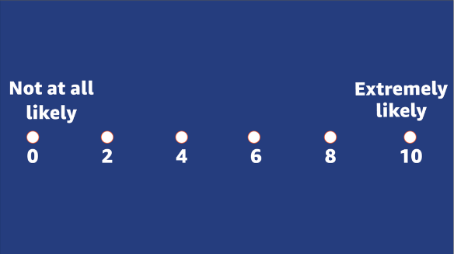 | Read the question and on-screen answer choices to students. “On a scale from 0-10, how likely are you to recommend this FC Tour to a friend?”  Say: “We have two more trivia questions to close out the tour and then we’ll find out who our winner is!”
36-37  0 min |  | Read the first question and on-screen answer choices to students. “A sensor is a piece of hardware”  Answer: True  Read the second question and on-screen answer choices to students. “Data and information such as an item’s height and weight, are stored in a ____.”  Answer: A database
38  0 min | 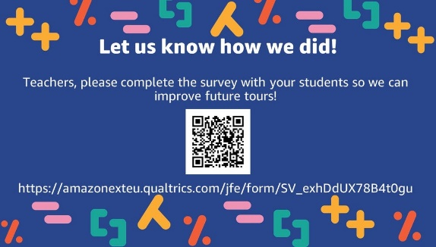 | Teachers only: Scan the QR code on this slide or visit the link to take a survey. Please do not have students complete this survey as they have already answered the questions in previous slides in the Kahoot.
39  30 sec | 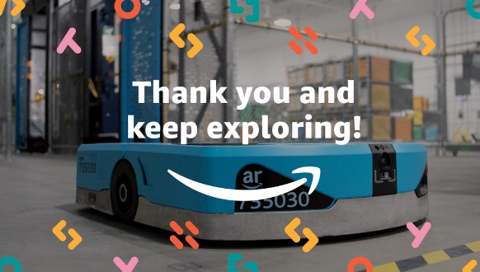 | Say: “I hope you enjoyed your virtual school trip and learned a lot about how computer science, robots, and people work together to deliver customer orders at Amazon.”  You may skip to the end for the podium, or explore some of the extension activities from Amazon Future Engineer.

