Thank you for joining us on the Prime Video Tour on Kahoot!
In this Career Tour, we’ll tell the story of how content from film and TV studios ends up streaming on Amazon Prime Video and we’ll also take a look at the people who make that possible. Use this facilitation guide to provide an excellent tour experience for students at home or in the classroom!

Prepare for the tour
- Review the key learnings and facilitation guide document below. Click through the tour (link below) on your own.
- Distribute graphic organiser (PDF, Word) to students if desired.

Select your tour style
- Review the key learnings and facilitation guide document below. Click through the tour (link below) on your own.


- Distribute graphic organiser (PDF, Word) to students if desired.
Host a tour with student devices  A host projects the tour to a group and students join to compete against each other from separate devices.  Full Tour (-30 minutes) |  | Project the tour without student devices  A host projects the tour to a group without students joining on separate devices.  Full Tour (-30 minutes) |  | Share the tour for independent student play  Students complete the tour by themselves on their own devices. Teacher cannot see student responses.  Full Tour (-30 minutes)

For additional support in setting up Kahoot, visit: https://support.kahoot.com/hc/en-us

Facilitate the tour
- Use the guide below to walk students through the tour. Ask students to share their thoughts or respond to questions to build more interaction.
- To advance slides, click “Got it” in the top right corner
- Use our Teacher Toolkit for optional follow-up activities and print completion certificates

Kahoot! Tips

If the video clips are playing too softly, check that the volume bar on the YouTube video is at maximum volume
There is no go-back feature. If you need to go back to a video, the links to the segments on
YouTube are provided in the facilitation guide below
Warning: Hitting the space bar auto-advances the slide with no go-back feature
Thank you for encouraging the next generation of future engineers!

Slide #: | Slide:  *some slide images are used as placeholders | Facilitation Tips: | Notes:
1  30 sec | 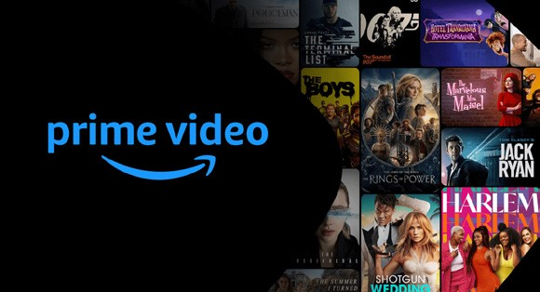  * | Say: “You may have heard of Prime Video before. You may even watch films and series on the platform.  Today we’re going to take a virtual school trip behind the scenes of Prime Video so you can learn about all the careers involved and how computer sciences makes it all possible.”
2  1 min | 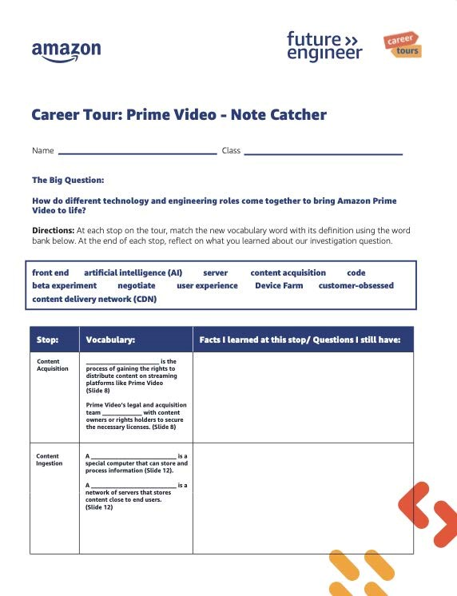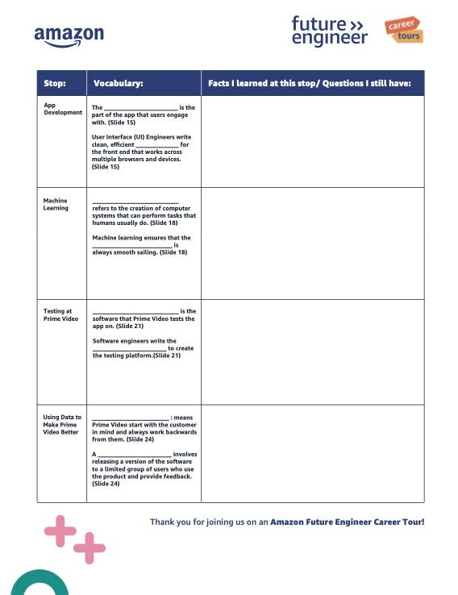 | If you’d like your students to access digital notes, have them access and create a copy of the student note catcher.  If using paper note catchers, this would be the time to distribute.
3  1 min | 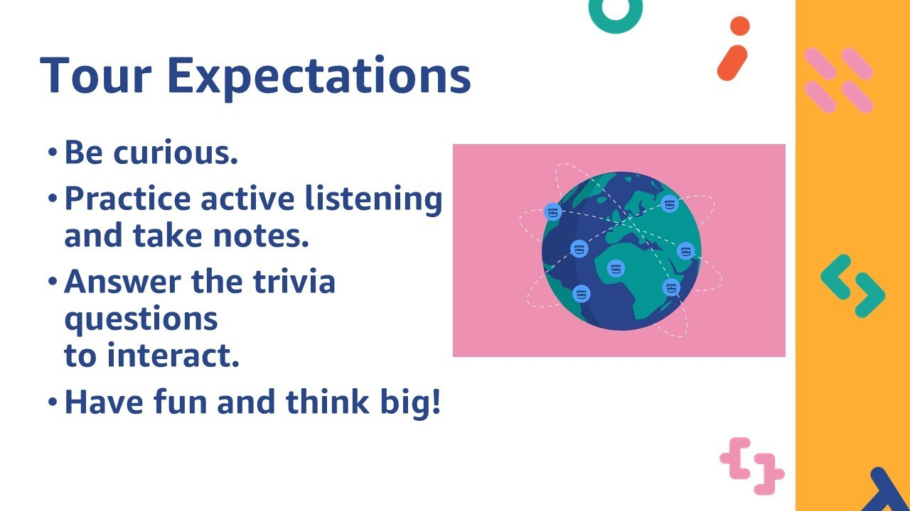  * | Set tour expectations with your class.  Read the expectations to students.  Say: “On the next slide you’ll answer if you agree or disagree with the statement ‘Right now, I am interested in career opportunities in computer science and technology.’ Remember, there is no right answer and this does not count towards your points.”

Slide #: | Slide: | Facilitation Tips: | Notes:
4  1 min 38 sec | 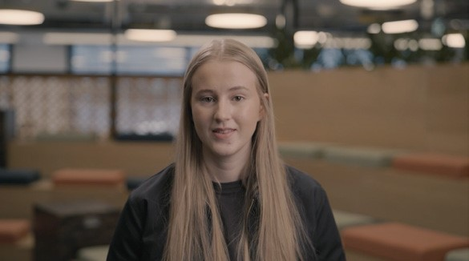 | Show Host Intro. The video is 1:38 in length.  After the video, say: “Before we move on to the next video, we have a pre-stop trivia question for you. Here it is: Amazon Prime Video allows users to stream what type of content? Remember points are awarded for getting it right AND how fast you answer!”
5  1 min | 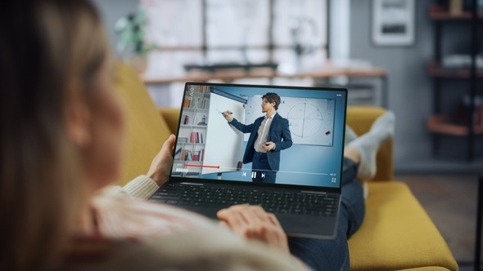  * | Read the question and on-screen answer choices to students. “What do you think was the fastest Amazon has ever delivered a customer order?”  Answer: On-demand  Say: “Let’s get back to the tour to learn about the content acquisition process.”
6  1 mi 59 sec | 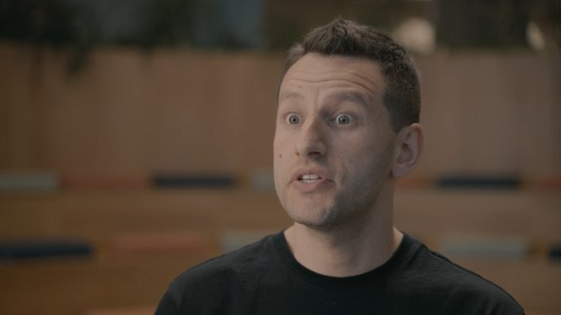 | Show Stop 1. The video is 1:59 in length.  After the video, say: “When I hit ‘Got it!’ / ‘Next’ we’re going to answer the two questions about what you just learned about content acquisition.”

Slide #: | Slide: | Facilitation Tips: | Notes:
7 – 8  1 min | 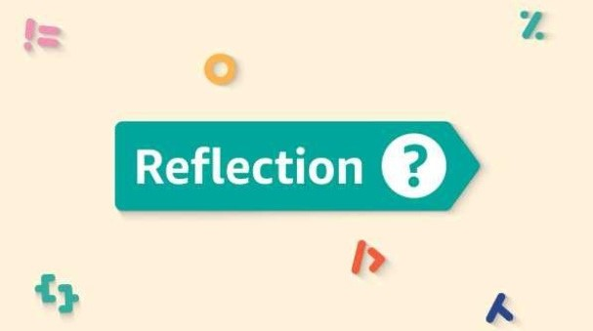 | Read the first question and on-screen answer choices to students. “Gaining the rights to stream and distribute  content on Prime Video is called…?”  Answer: Content acquisition  Read the second question and on-screen answer choices to students. “What must Prime Videos legal team gain before content is distributed?”  Answer: Necessary licences  Say: Are you ready for a pre-stop trivia question?
9  2 min 36 sec | 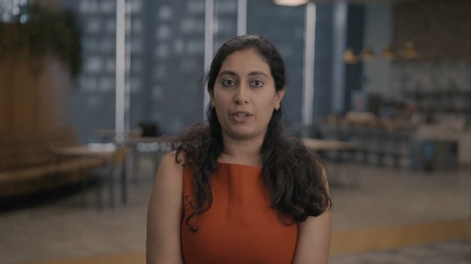 | Show Stop 2. The video is 2:36 in length.  After the video, say: “When I click ‘Got it!’ you’re going to answer the following question, ‘An example of metadata includes…”
10  20 sec |   * | Read the question and on-screen answer choices to students. “Where is content stored once it is acquired?”  Answer: AWS Cloud Storage  Say: “Let’s get back to the tour to learn about the content ingestion process.”
11  20 sec |  | Read the question and on-screen answer choices to students. “An  example of metadata includes…?”  Answer: All of these options!  Ask students if metadata such as programme descriptions influences what they watch on prime video.  Say: You know the drill by now, let’s answer a pre-stop trivia question before we move onto the next video.

Slide #: | Slide: | Facilitation Tips: | Notes:
12  20 sec |   * | Read the question and on-screen answer choices to students. “Before we start, what role do you think is responsible for owning app development at  Prime Video??”  Answer: Multiple roles come together to create the app.  Say: “Let’s get back to the tour to learn about the app development process.”
13  2 min 39 sec | 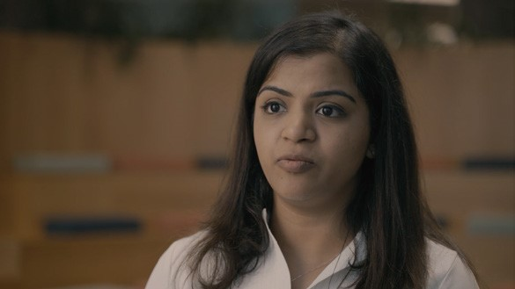 | Show Stop 3. The video is 2:39 in length.  After the video, say: “It’s time to reflect on what we’ve learned so far. You’re going to answer a question about app development at Prime Video.”
14  20 sec |  | Read the first question and on-screen answer choices to students. “What does ‘front-end’  refer to in the Prime Video app?”  Answer: The part of the app users interact with.  Say: Let’s head over to the pre-stop trivia question before our next stop.
15  20 sec |   * | Read the question and on-screen answer choices to students.  “What does ML stand for?”  Answer: Machine learning.  Say: “Let’s get back to the tour to learn all about machine  learning.”
16  2 min 18 sec | 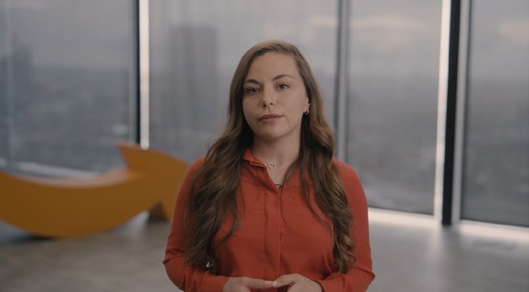 | Show Stop 4. The video is 2:18 in length.  Say: “Now that you have heard from Veneta, when I press  ‘Got it!’ / ‘Next’ you’ll answer the question “What is the primary role of an ML engineer?”

Slide #: | Slide: | Facilitation Tips: | Notes:
17  20 sec |  | Read the question and on-screen answer choices to students. “What is the primary role of an  ML engineer??”  Answer: Developing machine learning models.”  Say: Let’s have a go at the pre-stop trivia question next.
18  20 sec |   * | Read the question and on-screen answer choices to students. “Once content is acquired and ingested, it is ready to be streamed straight away. True or false??”  Answer: False  Say: “That’s right! Before content is streamed, it goes through the testing process. Let’s get back to the tour to learn all about testing at Prime Video.”
19  2 min 29 sec | 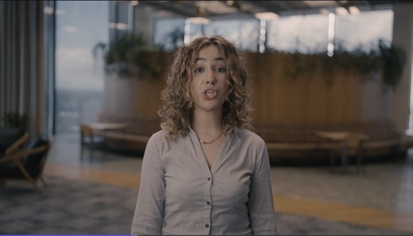 | Show Stop 5 The video is 2:29 in length.  After the video, say: “It’s time to reflect on our investigation question. You’ll answer a question about what devices Prime Video runs on during the testing phase.”
20  20 sec |  | Read the first question and on-screen answer choices to students. “What devices does Prime Video run on during the testing phase?.”  Answer: All of these devices and tonnes more!  Say: Let’s have a go at the pre-stop trivia question next.

Slide #: | Slide: | Facilitation Tips: | Notes:
21  1 min 49 secs | 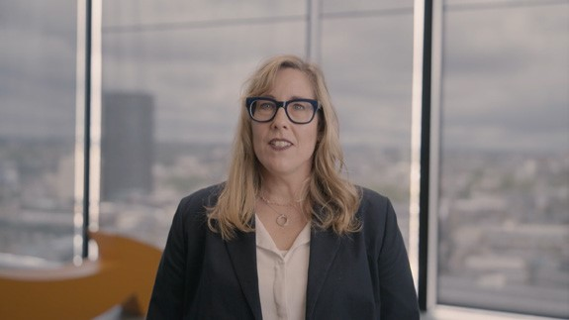 | Show Stop 6. The Video is 1:49 in length.  After the video, say: “As you can see, customers are super important at Amazon, because their feedback helps Prime Video to make the app even better. Let’s now answer a trivia in the next slide!
22  25 sec |  | Read the question and on-screen answer choices to students. “Which of the following statements best reflects  Amazon's Leadership Principle of  "Customer Obsession"??”  Answer: Continuously striving to earn and keep customer trust.  Say: “Before we go to our final video, let’s answer the pre-stop trivia question!.”
23  5 min |   * | Read the question and on-screen answer choices to students. “Of the careers you saw today, which interests you most…Machine learning engineer, Legal, Product Manager, Software engineer, Director or ICT Apprentice?  Answer: Students can choose different options.  Ask students why they choose that particular career. Engage in a class discussion.  Say: “Let’s get back to the tour to wrap up on what we have learned today”
24  1 min 13 sec | 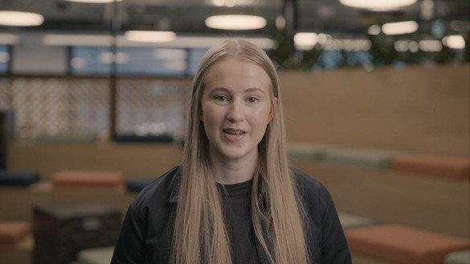 | Show Host Outro. The video is 1:13 in length.  After the video, say: “Now that the tour has come to an end, let’s reflect on what we have learned with some rapid-fire review and poll questions.”
25  10 sec | 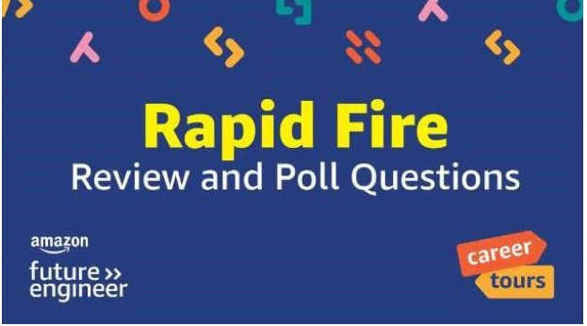 | Say: “Some of the questions will be polls, and some will be quiz questions and worth points. As a quick reminder, poll questions are worth 0 points.”

Slide #: | Slide: | Facilitation Tips: | Notes:
26  20 sec |   * | Read the question and on-screen answer choices to students. “What role at Prime Video is responsible for monitoring the overall functionality of the Prime  Video app?.”  Answer: Software Engineer  Let’s go for another trivia question!
27  20 sec | 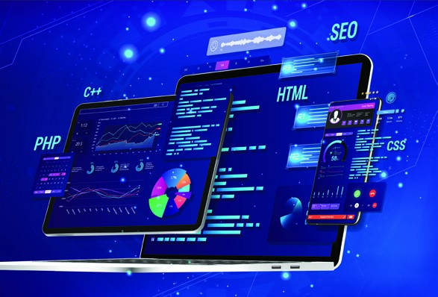  * | Read the question and on-screen answer choices to students. “What role at Prime Video is responsible for writing the test suites to test the application once both the front end and back end are ready?.”  Answer: Software Development  Engineer in Test  Let’s go for another trivia question!
28  20 sec | * | Read the question and on-screen answer choices to students. “What role at Prime Video is responsible for ensuring content has the necessary licenses to be  distributed on Amazon Prime??.”  Answer: Legal  Let’s go for another trivia question!
29  20 sec |   * | Read the question and on-screen answer choices to students. “What role ensures Prime Video’s video quality is crystal clear and  subtitles perfectly synced?.”  Answer: Machine Learning Engineers  Let’s go for another trivia question!
30  20 sec | 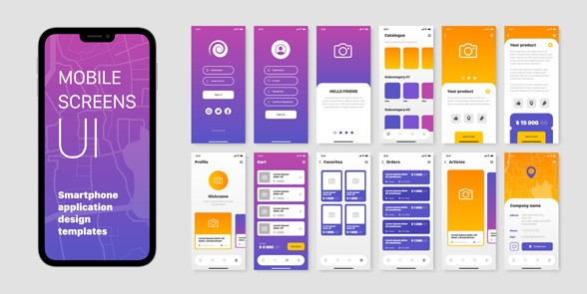  * | Read the question and on-screen answer choices to students. “One of the roles explored today was a UI Engineer. What does UI stand for?”  Answer: User Interface  Let’s go for another trivia question!

Slide #: | Slide: | Facilitation Tips: | Notes:
31  20 sec | 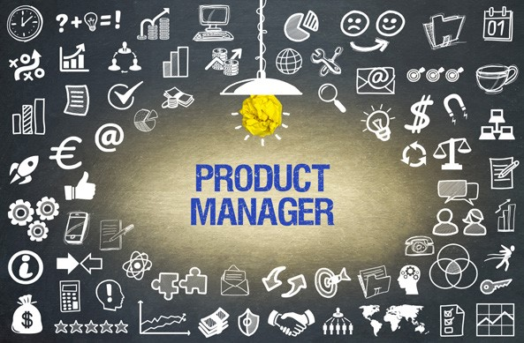  * | Read the question and on-screen answer choices to students. “What does a Product Manager at Prime Video do?”  Answer: Define the vision for the product  Let’s go for another trivia question!
32  20 sec |   * | Say: “Our next question is a poll. It is worth 0 points, but you’re going to think back before the tour. How interested were you in career opportunities in computer science and technology?”  Say: “Let’s finish with our poll questions.”
33  30 sec |   * | Read the question and on-screen answer choices to students. “Overall, rate your satisfaction of this tour on a scale of 1-5.”  Say: “Let’s go to another poll question”
34  30 sec |   * | Read the question and on-screen answer choices to students. “This tour increased my interest in pursuing careers in computer science, technology, and engineering.”  Say: “Let’s go to another poll question”
35  30 sec | 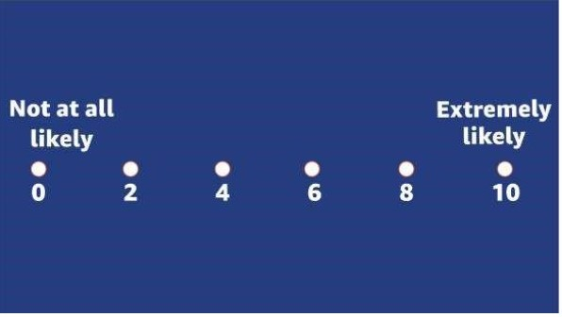 | Read the question and on-screen answer choices to students. “On a scale from 0-10, how likely are you to recommend this  Amazon Prime Career Tour to a friend?”
36  30 sec | 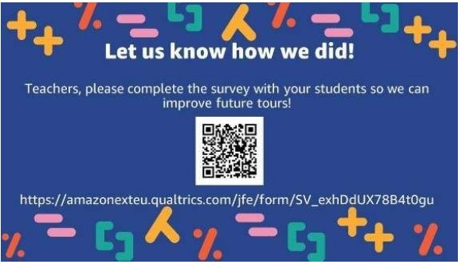 | Teachers only: Scan the QR code on this slide or visit the link to take a survey. Please do not have students complete this survey as they have already answered the questions in previous slides in the Kahoot.

Slide #: | Slide: | Facilitation Tips: | Notes:
40 30 sec | 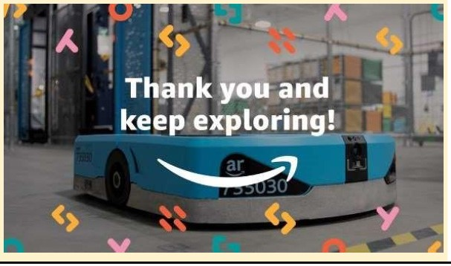 | Say: “I hope you enjoyed your virtual school trip and learned a lot about how computer science and the people who work together to bring Prime Video to  life.”  You may skip to the end for the podium, or explore some of the extension activities from  Amazon Future Engineer.

