Alexa Skills Inventor - Lesson 1: Intro to Voice AI
How does voice artificial intelligence (like Amazon Alexa) work?
Lesson Overview:
This lesson is aimed at students aged 13+ and introduces the world of AI with a hands-on coding experience using MIT App Inventor. Students will explore the impact of AI in everyday life and uncover the basics of how AI works through utterances and intents.

First, students execute and modify a Cosmic Question example where a random fact about space is selected and provided to the user. Students then go on to create an additional intent where they can ask Cosmic Question to provide a fact about a particular planet. The lesson concludes with a class discussion and a final survey. Beyond the one our lesson, resources are provided so that students can make their own solution from scratch around a theme or context of their own.
Objectives:  After this lesson, students will be able to:  - Explain the basics of how voice AI works.  - Program an Alexa skill that provides a random fact about space.  - Program an Alexa skill that can recite random space facts which are more targeted.  - Explain how Alexa uses AI to determine what users really mean by their commands (or utterances). | Timings:  - AI Introduction Slides (8 minutes)  - Voice AI Basics and Definitions (7 min)  - Coding Mission 1: Space Facts! (20 min)  - Coding Mission 2: New Intent (20 min)  - Closing Discussion & Survey (5 min)  Total: 60 minutes. Mission 3 is provided in the slides in case students wish to develop their own app from scratch following the lesson through a subsequent lesson or enrichment opportunity.
Key Learnings:
- Artificial Intelligence (AI): The development of computer systems to perform tasks that normally require human intelligence.
- Voice AI: technology that recognises human voices, interprets their meaning, and offers a response in return.
- Voice AI devices (like Alexa) begin listening when someone “wakes it up” by saying a preprogrammed wake word. The Alexa device then listens to what the user says (their utterance) and uses AI to determine what the user wants the device to say/do in response (the user’s intent).
  - Wake Word: a pre-programmed word that triggers a voice AI device
  - Utterance: a question or command a user makes to a voice AI
  - Intent: the desired response to a question or command made to a voice AI
Wake Words | Utterances  Things You Might Say | Intent  Your Desired Response
“Alexa” “Amazon”  “Computer” “Echo”  “Ziggy” | “What time is it?” | “The time is 3:45pm”
“Alexa” “Amazon”  “Computer” “Echo”  “Ziggy” | “What’s the hour?” | “The time is 3:45pm”
“Alexa” “Amazon”  “Computer” “Echo”  “Ziggy” | “You got the time?” | “The time is 3:45pm”

- To program an Alexa skill, you will need to use computer science, including the following concepts:
  - Function: a block of reusable code used to perform an action
  - String: a series of characters like letters or numbers
  - Variable: a value that can change

Lesson Preparation:
- Create an MIT App Inventor Account for the Alexa Skills Inventor program here.
- Create and print out your randomised student logins (inside the Alexa Skills Inventor portal).
- Review the Lesson Slides and complete the activities using the Student Worksheet.
- Rehearse, gather any needed materials, and get ready to have fun!
Materials needed:
For Teachers:  - MIT App Inventor Account for the Alexa Skills Inventor program (create it here).  - Print PDF of Alexa Skills Inventor Randomised Student Logins - each card will provide students with a unique anonymous login. Cut these out before class. These also can be shared out virtually if easier.  - starting-project.aia file (make available for students to import this into MIT App Inventor)  - Lesson Slides with videos  - This lesson plan as your guide | For each student:  - A computer with internet  - Headphones (optional)  - Student Worksheet (optional)

Lesson Outline:
Use the Lesson Slides to facilitate. A suggested script is provided in “Notes” and in the guide below.
Introduction (8 minutes)
1 | 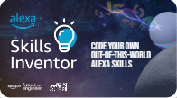 | Introduce the lesson mentioning the focus on AI and explore and initial understanding of this with the students. Ask students if they have seen/used an Alexa (or similar) device and how they have interacted with it.  Try to explore their wider understanding of AI and ask for ideas about how AI is used to make the world a better place.
2 | 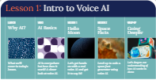 | Share the progress that students will be making through the lesson and the ‘hook’ of using MIT App Inventor to create a space facts application. Share how students will then be extending the code provided so that the application can be more targeted and better respond to the user.
3 | 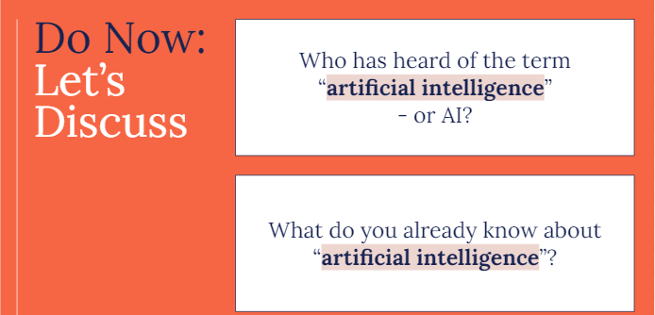 | Ask students their understanding of AI. Begin with examples within their home and then try to move their thinking towards the wider world such as the use in healthcare, agriculture etc.  You can also ask pupils in pairs to come up with a definition which can then be compared to the definition on the following slide.
4 | 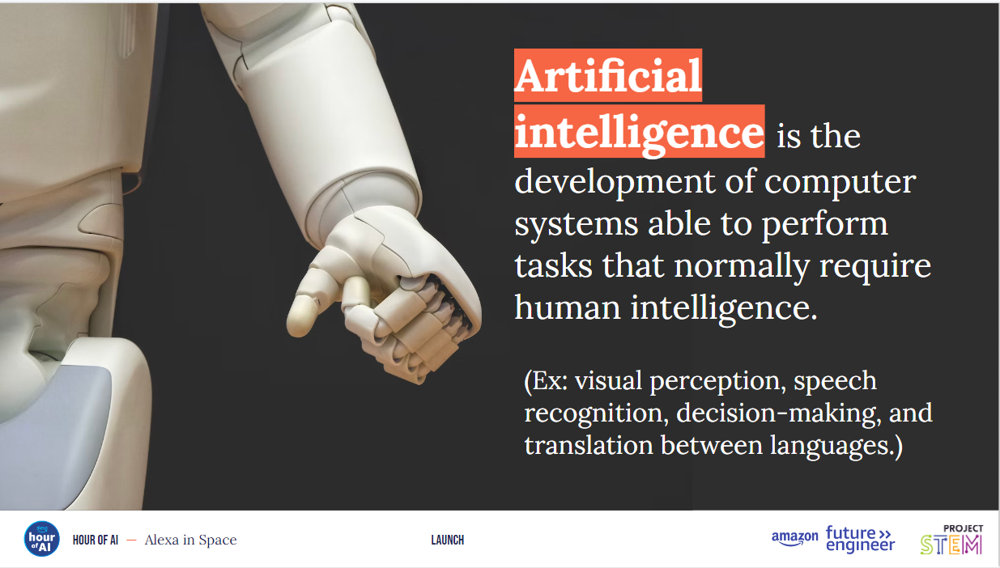 | Ask a student to read out the description on the slide and then ask for definitions of key words such as development, systems, intelligence.
5 - 13 | 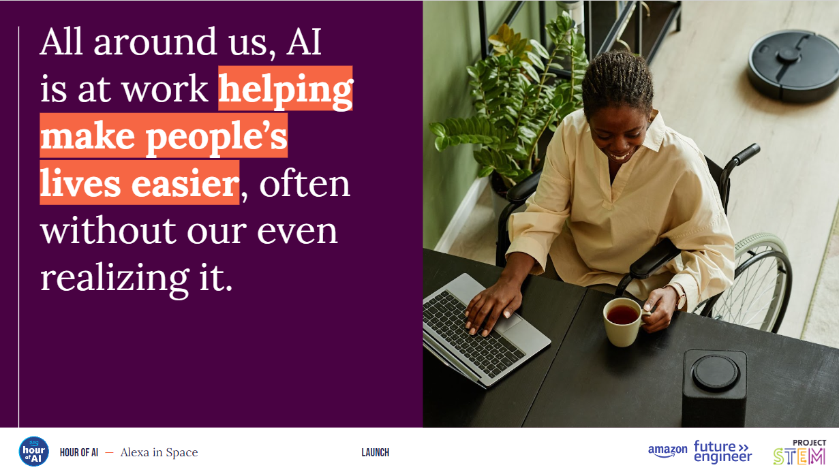 | Now, share a range of examples from this slide to slide 13, working through them quickly to expand the understanding and impact of AI and the breadth and context for its use in society.
 | 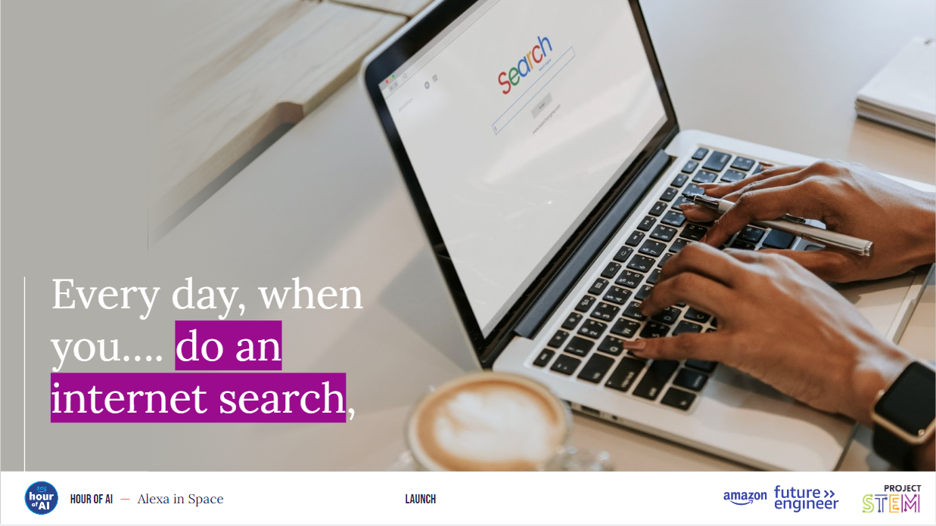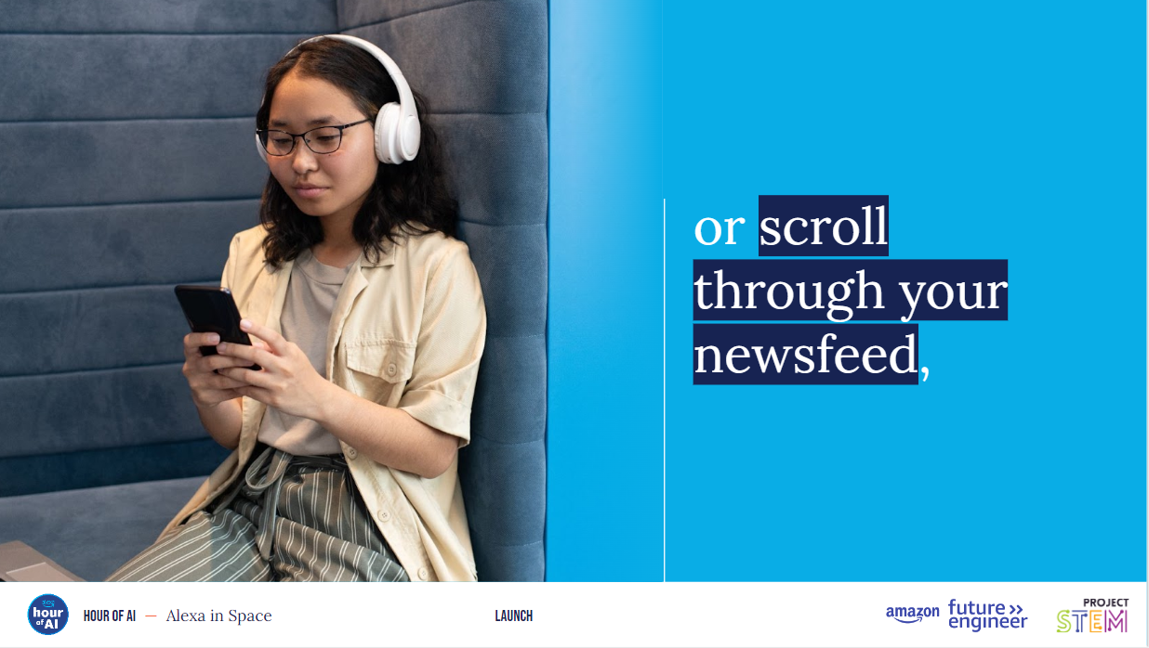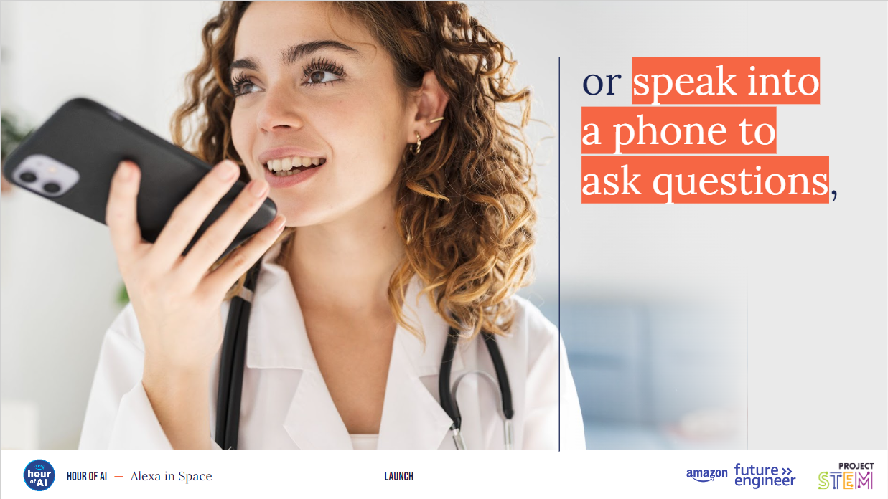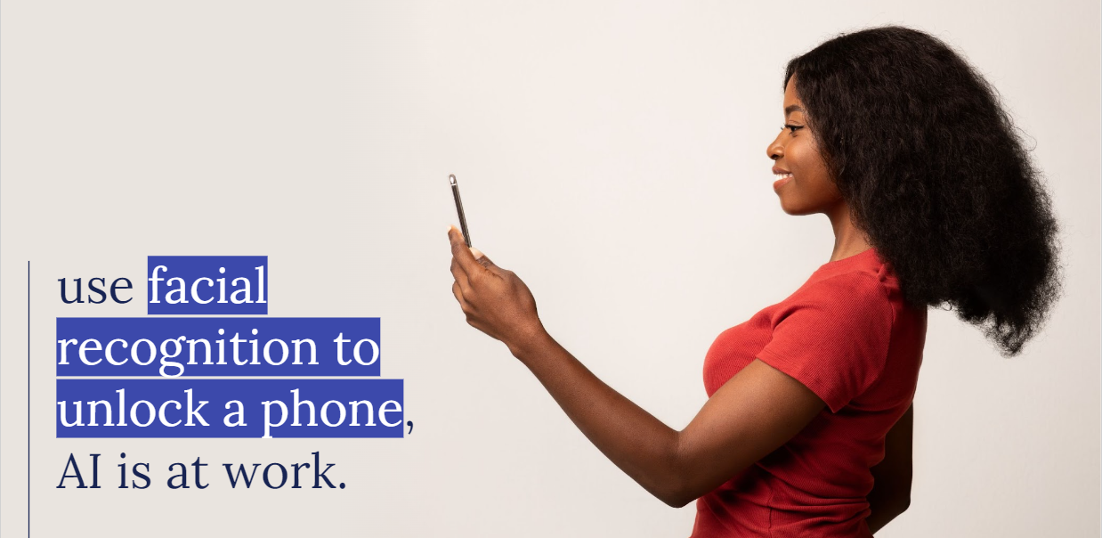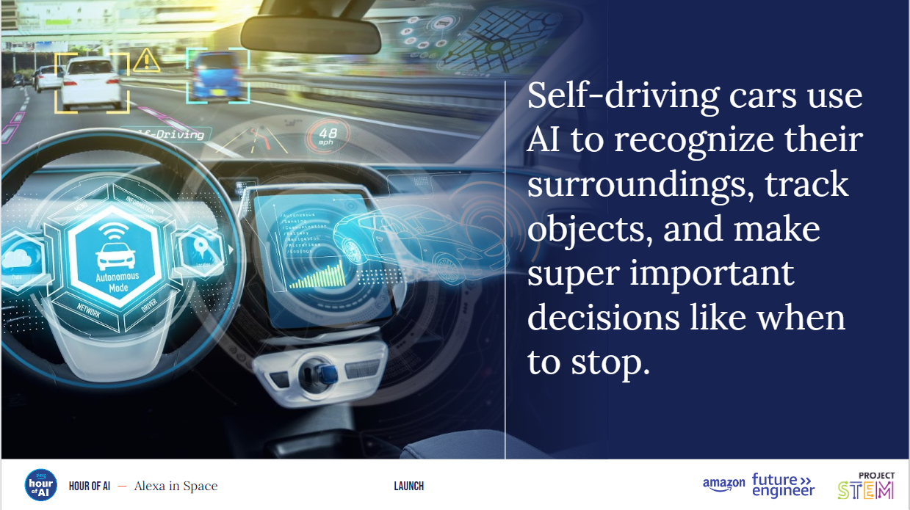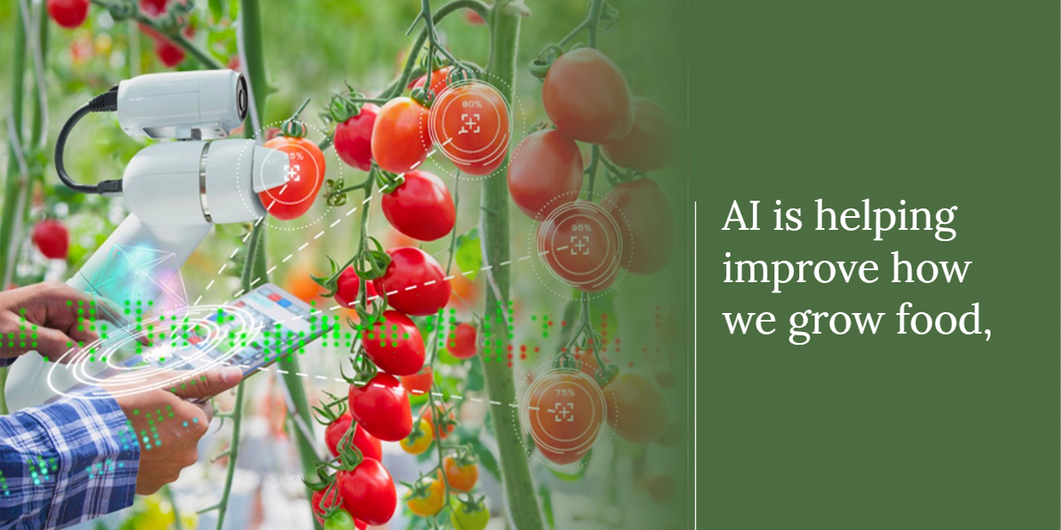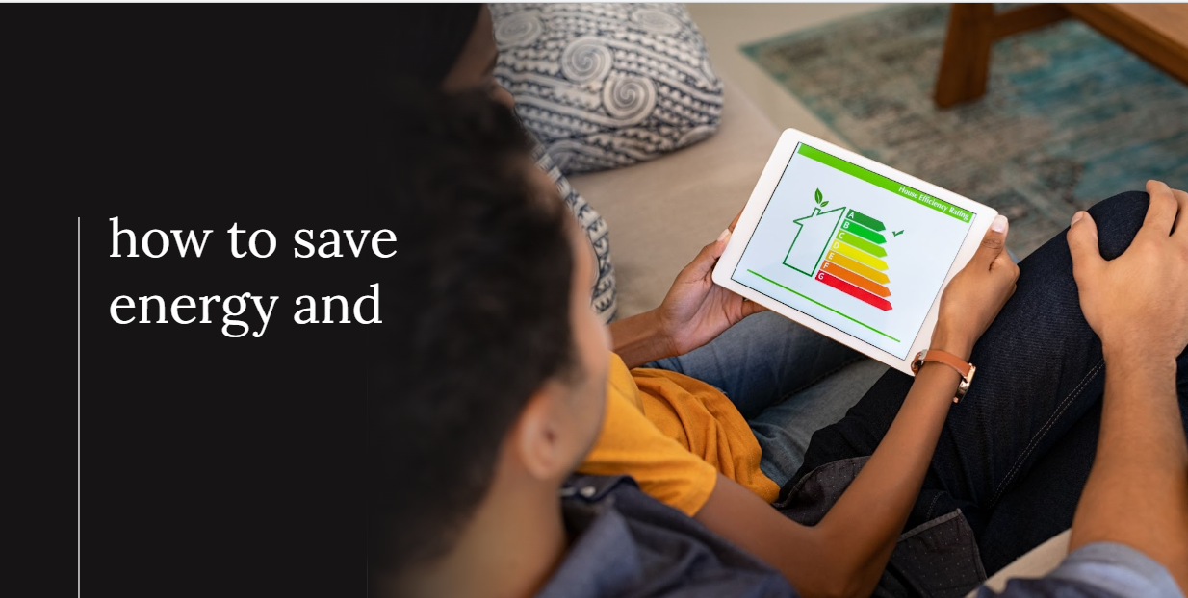
14 | 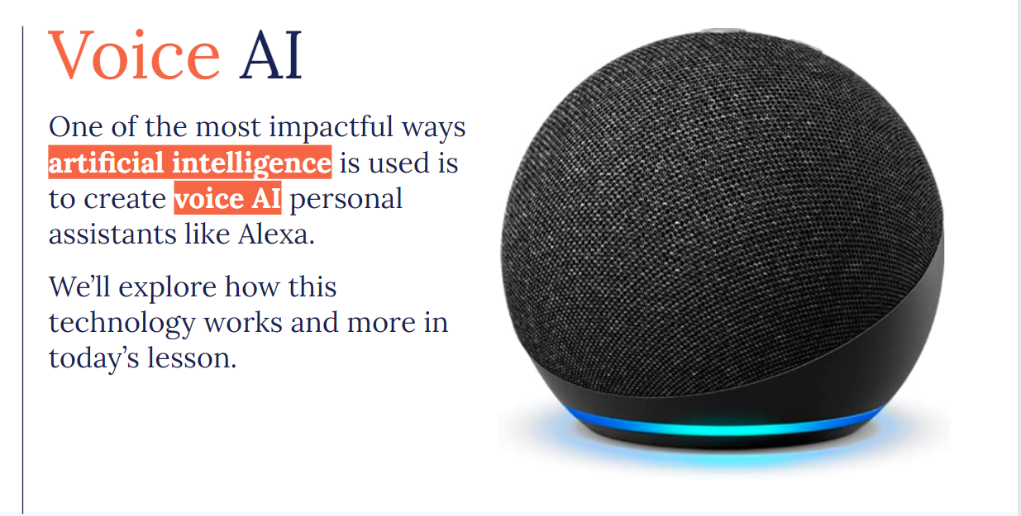 | Introduce how this lesson will focus on voice AI with personal assistants like Alexa and how an understanding of voice AI can often be a good introduction from which the previous contexts are often built.
Voice AI Basics (7 minutes)
15 | 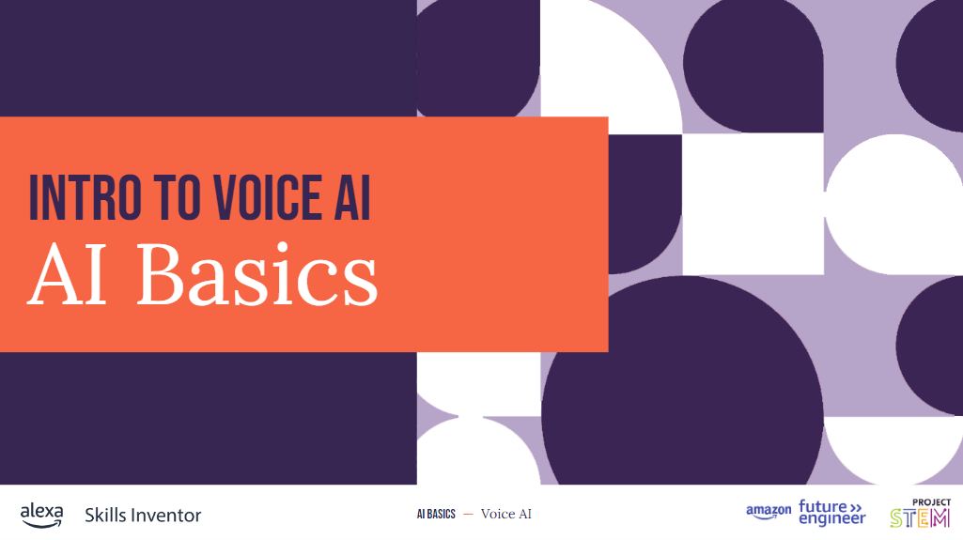 | Highlight that before students start coding, they’ll need to understand a little how voice AI works.
16 | 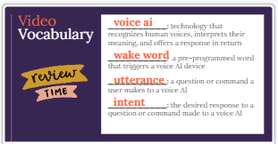 | Share the key words with students and highlight how these terms will be used in the coding environment so it is important to have a good understand of what each means.  (optional) Students can complete page 1 of the Student Guide where students can fill in the missing words for the row Voice AI Basics.
17 | 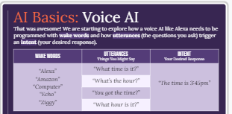 | Highlight the three big components of voice AI – wake words, utterances, and intents. You can provide these short definitions to the class:  Wake words - tells Alexa to listen, the utterances are the different ways you might ask Alexa to do something, and the intent is the desired response.  Utterances - are the different ways you might ask Alexa to do something, and the intent is the desired response.  Intent – the desired response.
18 | 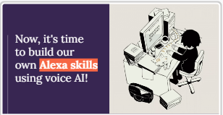 | Lead into the practical part of this lesson by sharing that we are going to now view and edit an app using voice AI.
Coding Mission 1: Cosmic Question - Space facts! (20 minutes)
19 | 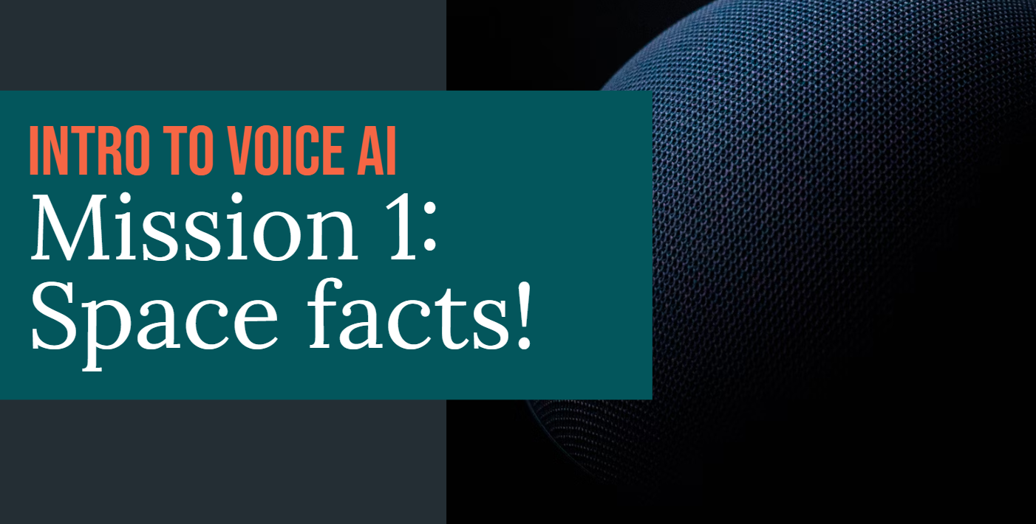 | Introduce to students that they will be starting by exploring an app that provides space facts that is called Cosmic Question.
20 | 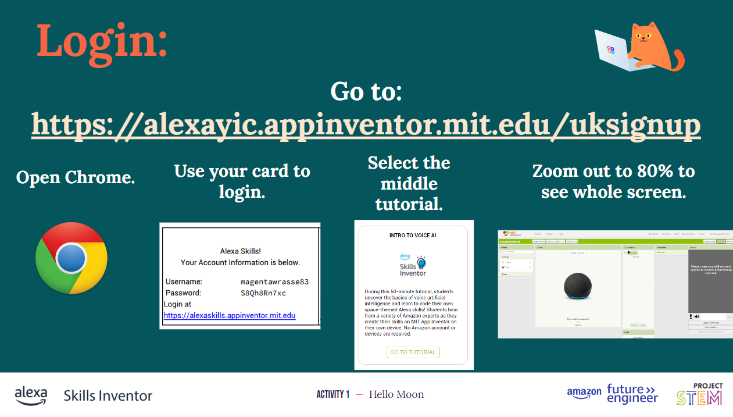 | Share the link with students to login and provide them with their randomised login card so they have the necessary login credentials. It might be necessary to show students how to zoom out to 80% of the screen so they can see the wider options and environment in MIT App Inventor.
21 | 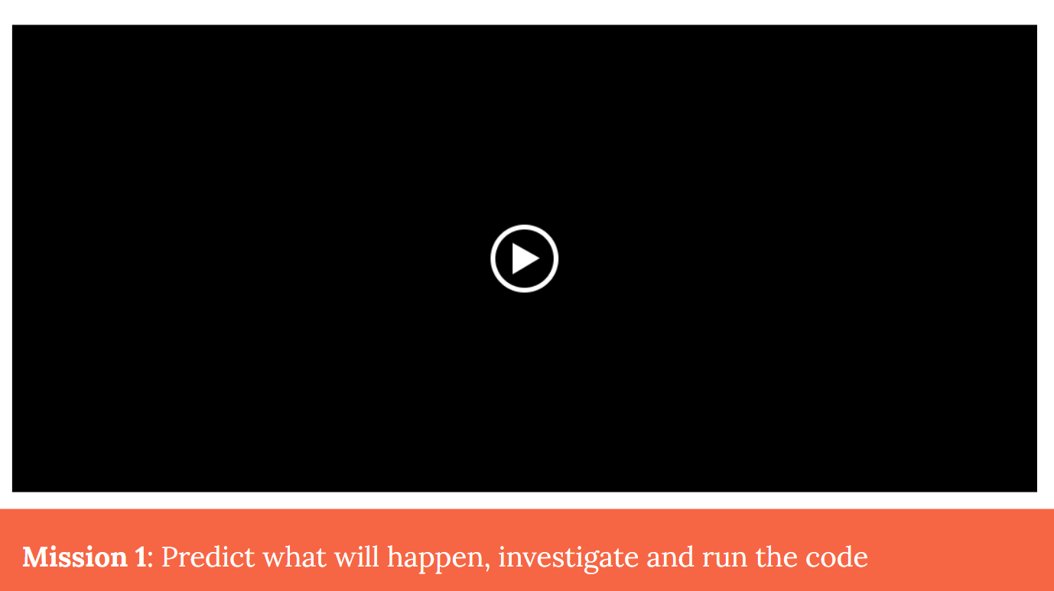 | Play the video which provides a quick demonstration of the MIT App Inventor environment and sets out the task (which is provided on the next slide).  (optional) Point students to the Student Guide where they can find some directions for Mission 2.
22 | 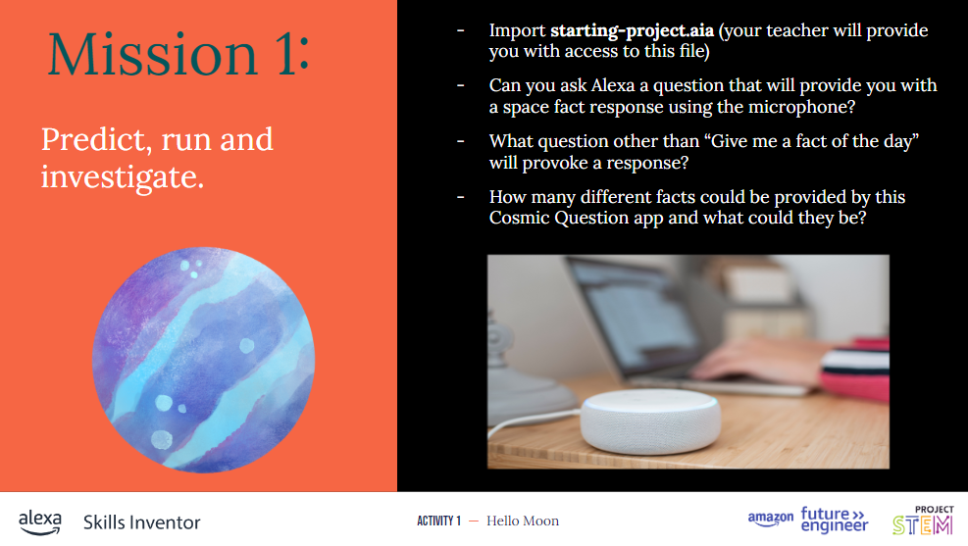 | Ask students to use the microphone button to ask the question “Give me a fact of the day” as in the previous video and for them to look around to find the other statement that could be used to provoke a response.  Show students how to find the block code editor so they can read through the code and share with each other or the whole class, what the three different facts are that could be randomly selected.
23 | 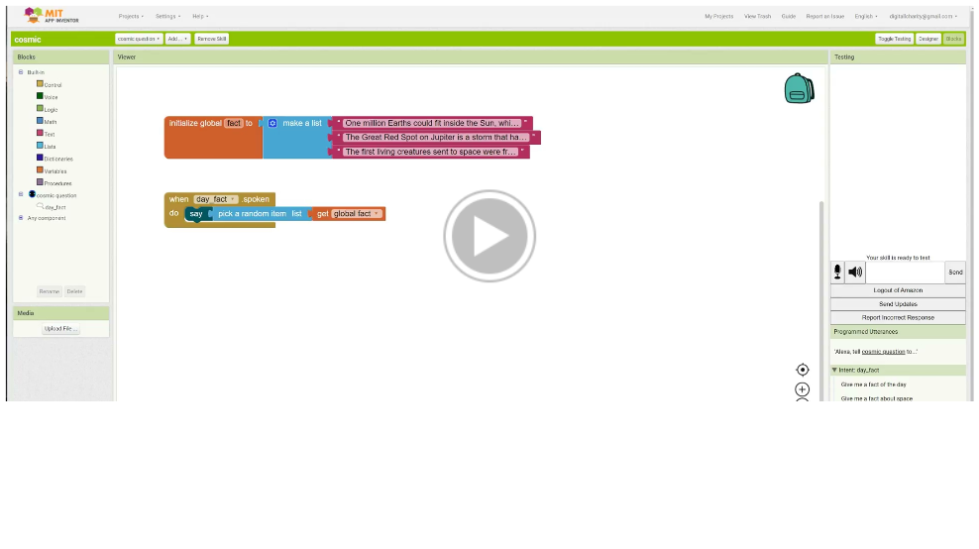 | Play the video which provides a quick demonstration of how to extend the list to include additional items and therefore extend the number of responses that can be selected.
24 | 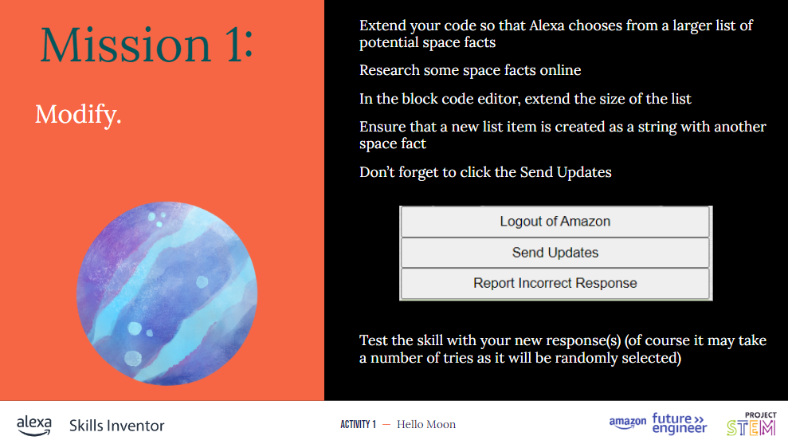 | Highlight the use of strings (the text in the blocks that detail each fact) and the use of a global list object (for abstraction purposes use variable). Explain how a global variable is used for the list so that we can access it in different functions/procedures such as “when day_fact.spoken”.  Ensure students are aware that they need to click Send Updates before they test their solution. They may, of course, need to test their solution several times before their new fact is spoken by Alexa.
25 |  | Share with students that we will now be extending the Cosmic Question app to be more targeted.  (optional) Point students to the Student Guide where they can complete the vocab inserts for Mission 1
Coding Mission 2: New intent (20 minutes)
26 | 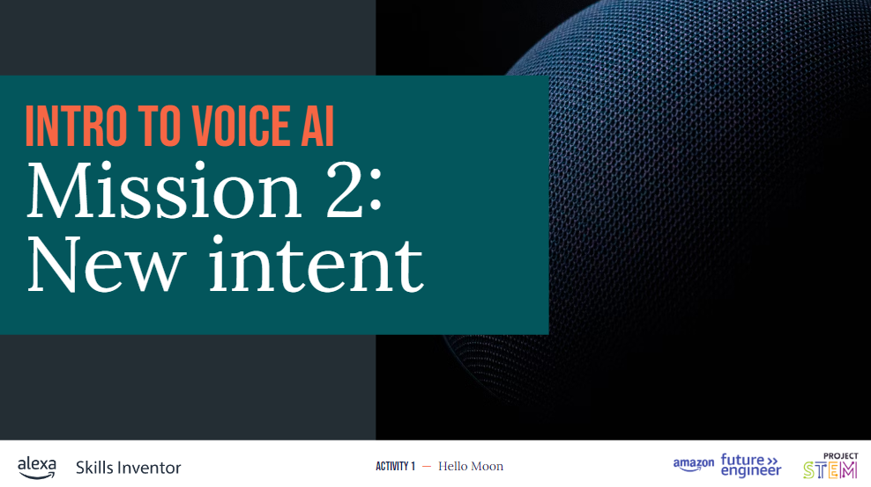 | Explain to students that they will now be adding a new intent – to generate responses related to a particular planet.
27 | 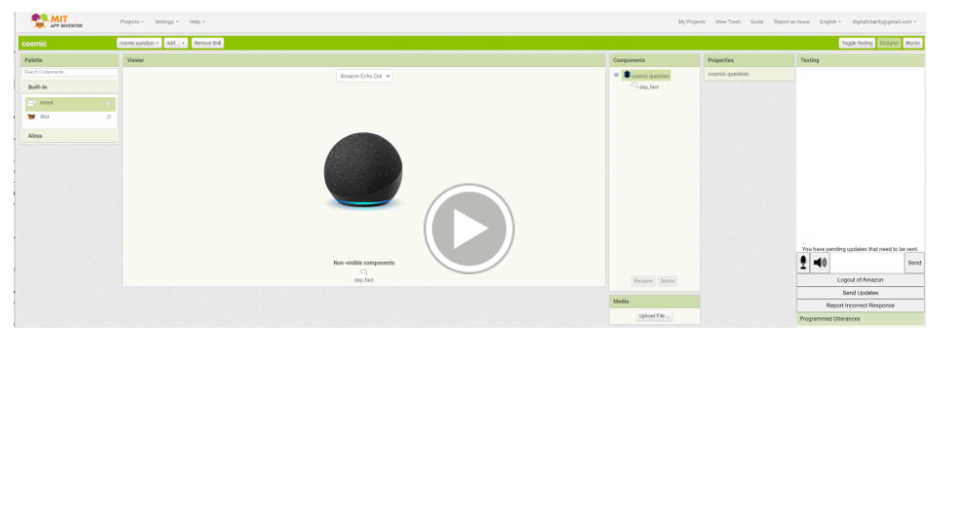 | Play the video which shows students how to create a new intent (in this case for facts about Mars) and how to add utterances that will trigger a new function created that will randomly select a statement from a new list about Mars.
28 | 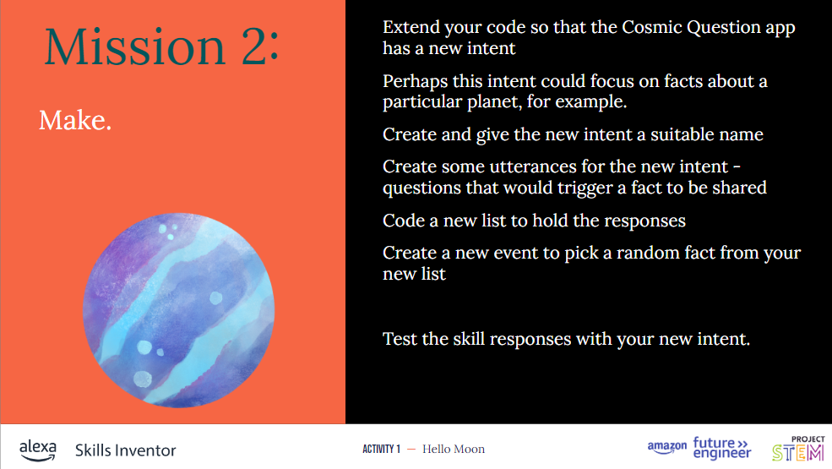 | Ask students to complete the activities on this slide. They may wish to revisit the video again to help them work through the activities. They can choose their own planet to gain facts about and could even use generative AI to collect the facts they wish to place within their code.  (optional) Point students to the Student Guide where they can find some directions for Mission 2.
29 | 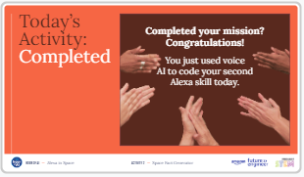 | Congratulate students on their amazing work and their introductory skills and knowledge in AI. Explain that if they access the slides outside of the lesson, they can revisit the videos to create their own app.
31 | 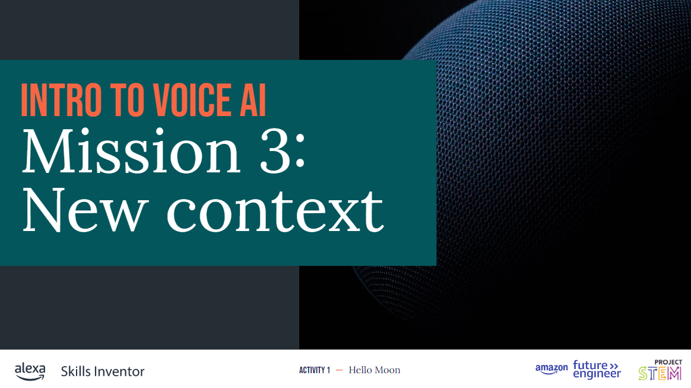 | Mission 3 is an optional task, good to share with students in case they want to go deeper and develop their own app from scratch.
31 | 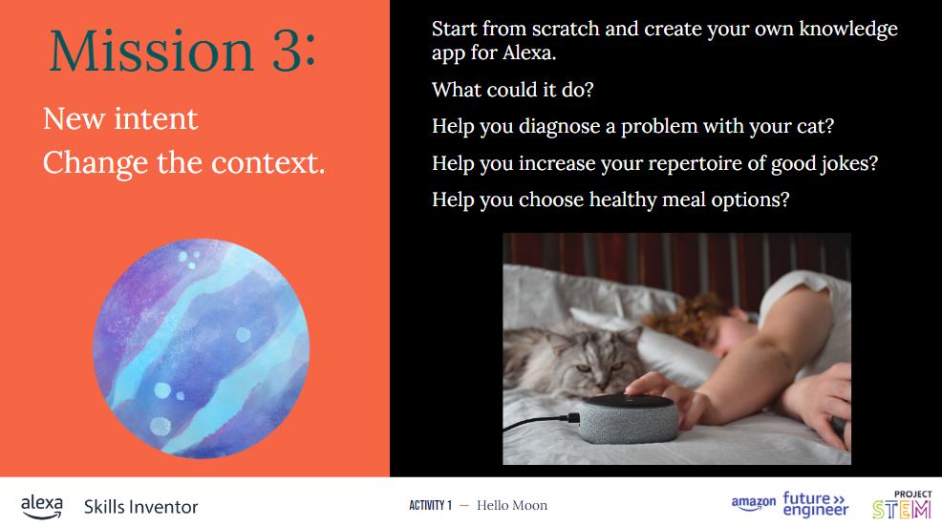 | Share the extended optional mission. If students don’t have the time to create their own app to solve a problem they have experienced then you can use this slide as an opportunity to explore what other contexts would be of interest to them.
Closing (5 minutes)
36 | 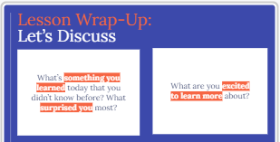 | Use this slide to help generate a discussion or for students to share in small groups about what they have learnt, what surprised them and what they would like to know more about.  (optional) Point students to the Student Guide note down their thoughts and then pair and share.

